**Table of Contents**

Test Case Report for Digital Key Generation Smart Contract 1

Screenshot 2

Test Case Report for Digital Key Generation Smart Contract

|  |  |  |  |  |  |  |
| --- | --- | --- | --- | --- | --- | --- |
| Test No. | User Story (Redeemer) | Conditions | Steps | Expected Output | Accepted Output | Result |
| 1 | DigitalKeyGeneration – Valid digital key generation by admin | • initiateCheckIn == True• adminPKH == testAdmin• digitalKey == ""• tx signed by testAdmin | Create DigitalKeyGeneration redeemer with digitalKey="generated_digital_key_456"; build txInfo signed by admin; call validator | Validator allows update; sets digitalKey | Update accepted and committed | ✅ Pass |
| 2 | DigitalKeyGeneration – Reject without admin signature | • initiateCheckIn == True• adminPKH == testAdmin• tx signed by non‐admin | Build txInfo signed by otherPkh; apply DigitalKeyGeneration; call validator | Validator rejects update due to missing admin signature | Update rejected | ✅ Pass |
| 3 | DigitalKeyGeneration – Reject when check‑in not initiated | • initiateCheckIn == False | Attempt DigitalKeyGeneration on datum with initiateCheckIn=False; call validator | Validator rejects update due to check‑in not yet initiated | Update rejected | ✅ Pass |
| 4 | DigitalKeyGeneration – Reject when key already exists | • digitalKey != "" | Attempt DigitalKeyGeneration on datum where digitalKey is already set; call validator | Validator rejects update due to existing digitalKey | Update rejected | ✅ Pass |
| 5 | DigitalKeyValidation – Valid digital key validation | • digitalKey != ""• isDigitalKeyValidated == False | Apply DigitalKeyValidation to set isDigitalKeyValidated=True; call validator | Validator allows update; sets isDigitalKeyValidated=True | Update accepted and committed | ✅ Pass |
| 6 | DigitalKeyValidation – Reject when digital key not generated | • digitalKey == "" | Attempt DigitalKeyValidation on datum with no digitalKey; call validator | Validator rejects validation due to missing digitalKey | Update rejected | ✅ Pass |
| 7 | DigitalKeyValidation – Reject when validation flag not set | • digitalKey != ""• redeemer leaves isDigitalKeyValidated == False | Apply DigitalKeyValidation but leave isDigitalKeyValidated=False; call validator | Validator rejects update due to isDigitalKeyValidated not set to True | Update rejected | ✅ Pass |

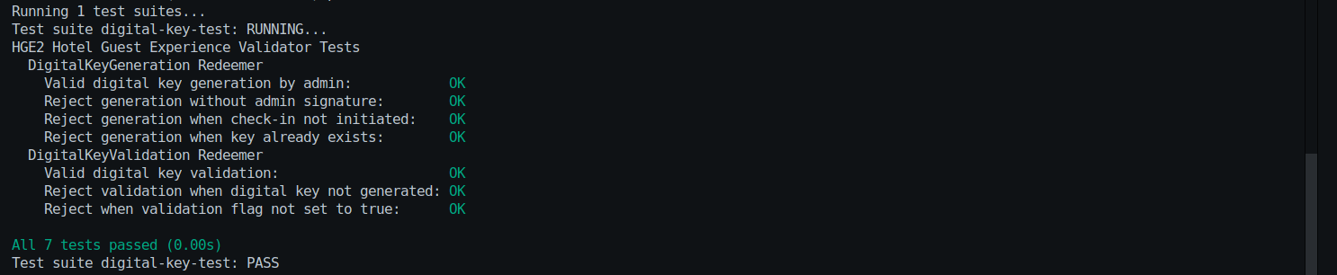**Screenshot**